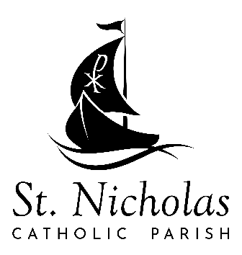
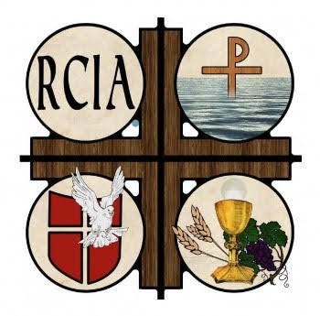
RCIA
Fall ’23 – Spring ‘24
Mondays – midday - 12:30-1:45p
Tuesdays – evening – 6:30-7:45p

Our gatherings are a combination of discussion, sharing, experience, and information. The topics covered will be different at each meeting depending on the participants stage of the RCIA process and the current needs of the community. Inquirers, baptized and unbaptized persons seeking knowledge of the Catholic faith, are welcome to join us at any time throughout the year. Holy Days of Obligation, holidays, and special events are noted in italics.
October
Mon – 2, 9, 16, 23
Tues – 3, 10, 17, 24

September
Mon – 11, 18, 25
Tues – 12, 19, 26

November
1 – All Souls Day
Mon – 6, 13, 27
Tues – 7, 14, 28
December
8 – Immaculate Conception
25 - Christmas
Mon – 4, 11
Tues – 5, 12
January
1 – New Years’ Day, Mary Mother of God (solemnity)
15 – Martin Luther King
Mon – 8, 22, 29
Tues – 9, 16, 23, 30

February
14 – Ash Wednesday
17 – Rite of Election

Mon – 5, 12, 19, 26
Tues – 6, 13, 20, 27

April
Mon – 8, 15, 22, 29
Tues – 2, 9, 16, 23, 30

May
12 - Ascension
19 – Pentecost (solemnity)
Mon – 6, 13 (final session)
Tues – 7, 14 (final session)

March
24 – Palm Sunday
31 – Easter Vigil

Mon – 3, 10, 17, 24
Tues – 4, 11, 18, 25

Revised 8-30-23
3510 ROSEDALE STREET NW, GIG HARBOR, WA 98335 (253)851-8850 WWW.STNICHOLASCC.ORG

